<https://www.youtube.com/watch?v=XrOc3PKYK8U>

**Dynamodb table creation :**

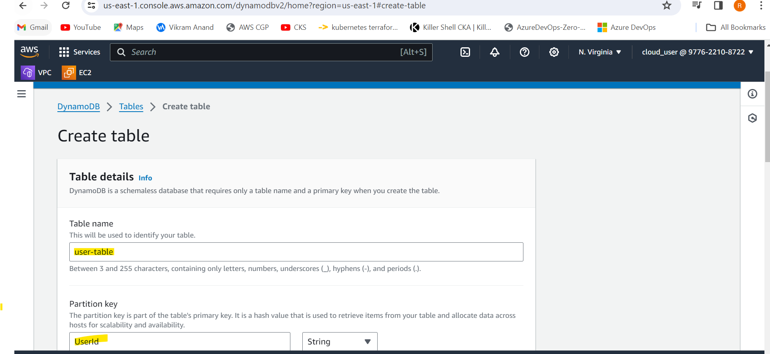

**Role creation for lambda-dynamodb integration**

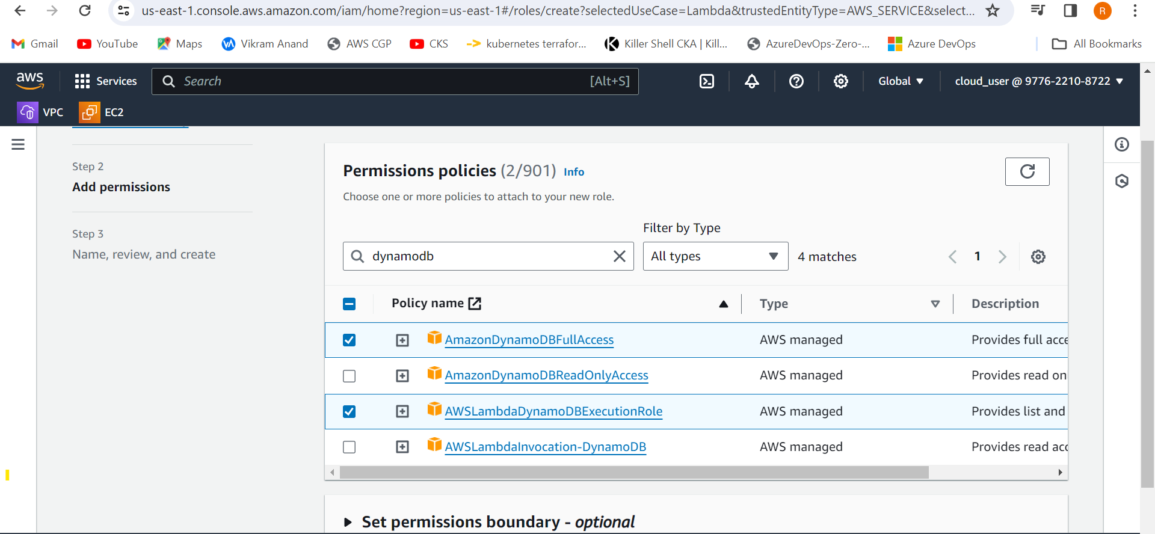

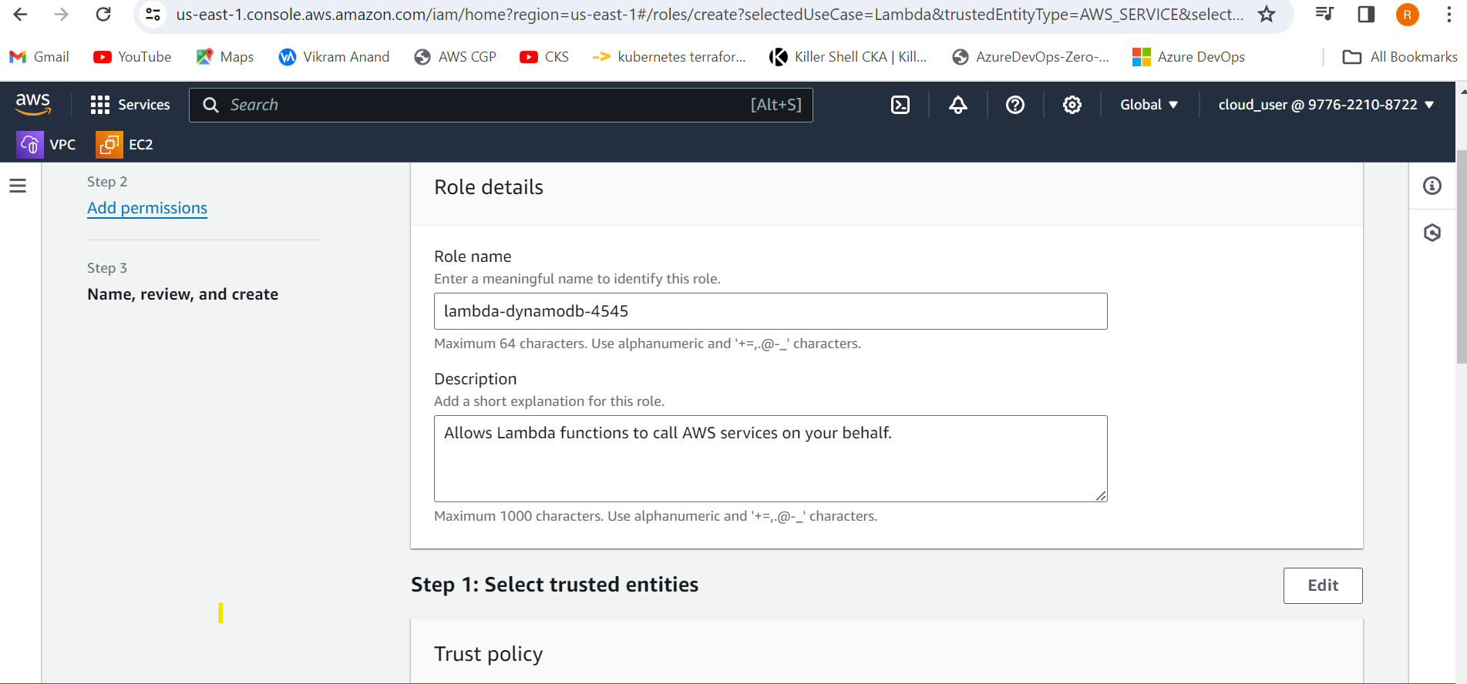

**Create a lambda function and attached the role**

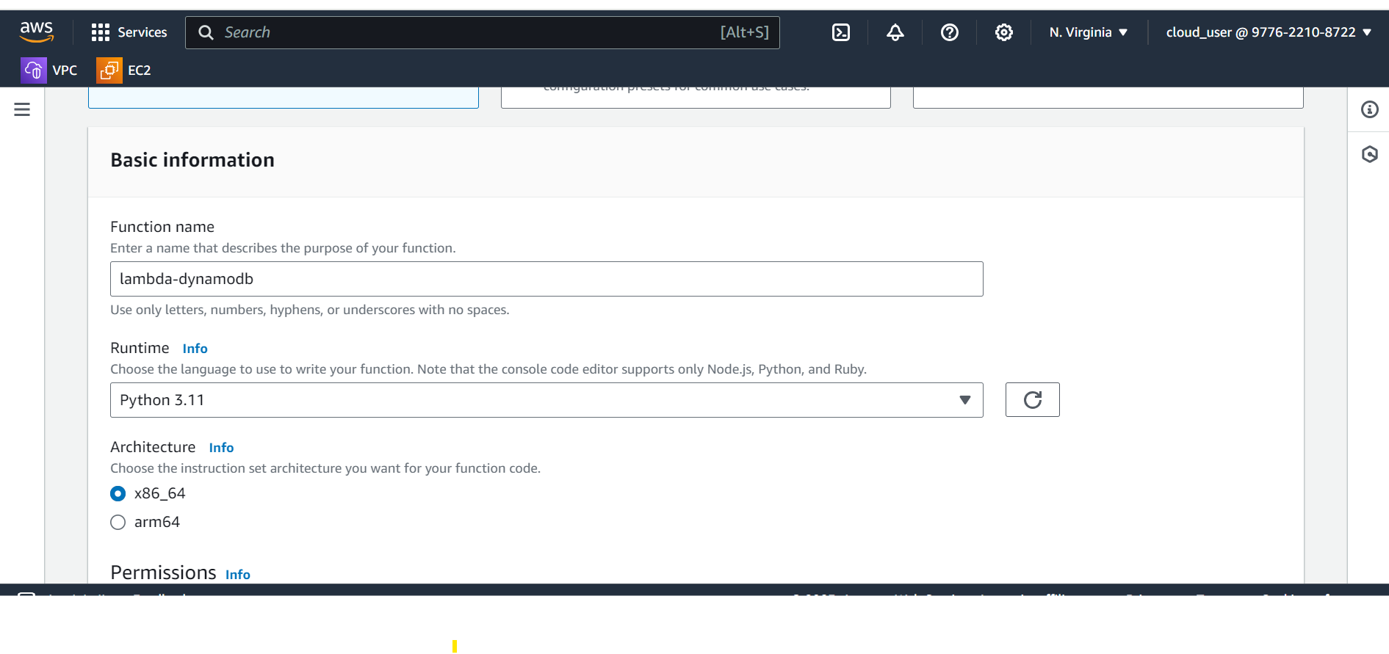

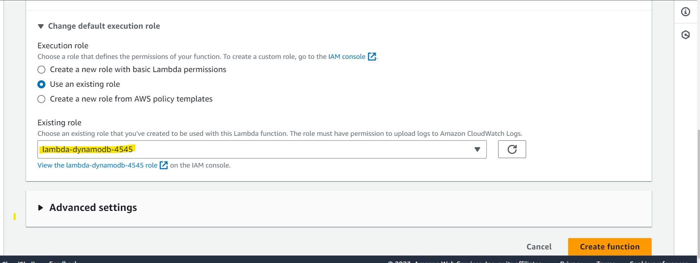

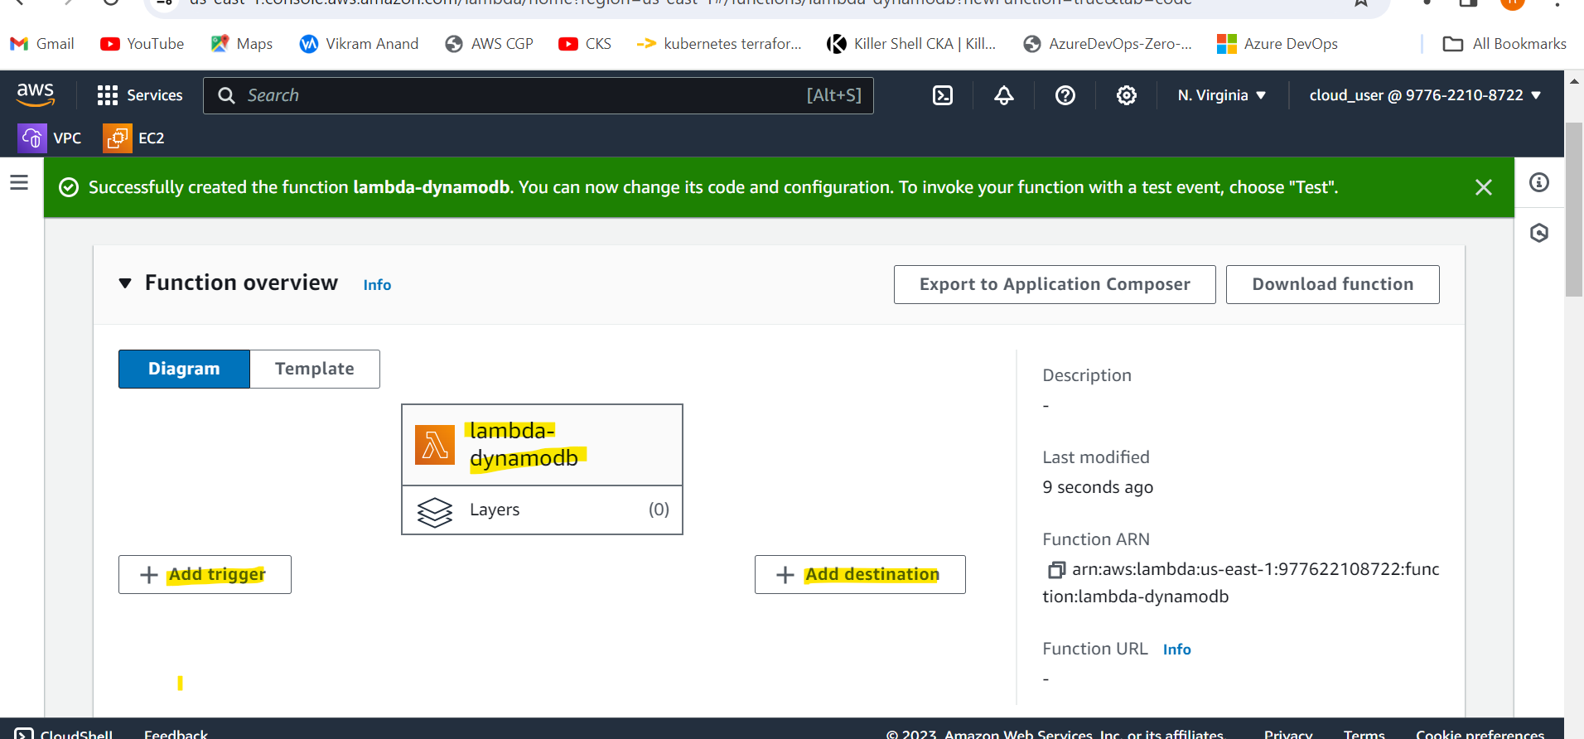

We use this python code - <https://github.com/gaurav157243/aws-projects/blob/main/serverless/lambda.py> in lambda

import boto3

import os

import json

def lambda_handler(event, context):

dynamodb = boto3.resource('dynamodb')

#table_name = os.environ.get('TABLE')

table = dynamodb.Table('user-table')

# Parse the data sent in the request payload

try:

request_data = json.loads(event['body'])

print(request_data)

user_id = request_data['UserId']

user_name = request_data['UserName']

email = request_data['Email']

except KeyError:

return {

'statusCode': 400,

'body': json.dumps('Invalid input data')

}

# Insert data into DynamoDB

data_to_insert = {

'UserId': user_id,

'UserName': user_name,

'Email': email

}

table.put_item(Item=data_to_insert)

return {

'statusCode': 200,

"headers": {

"Access-Control-Allow-Origin": "*", # Change this to the allowed origin(s) or '*' for any origin

"Access-Control-Allow-Methods": "POST, GET, OPTIONS", # Add other allowed methods as needed

"Access-Control-Allow-Headers": "Content-Type, Authorization" # Add other allowed headers as needed

},

'body': json.dumps('DynamoDB operations executed successfully!')

}

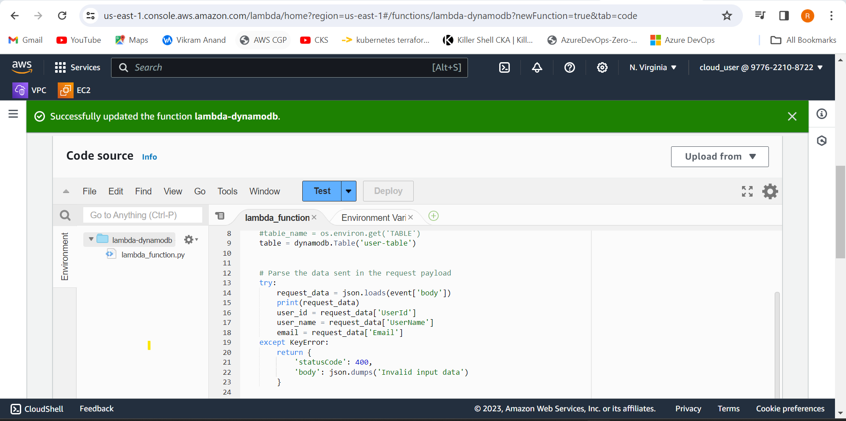

**Create a API gateway**

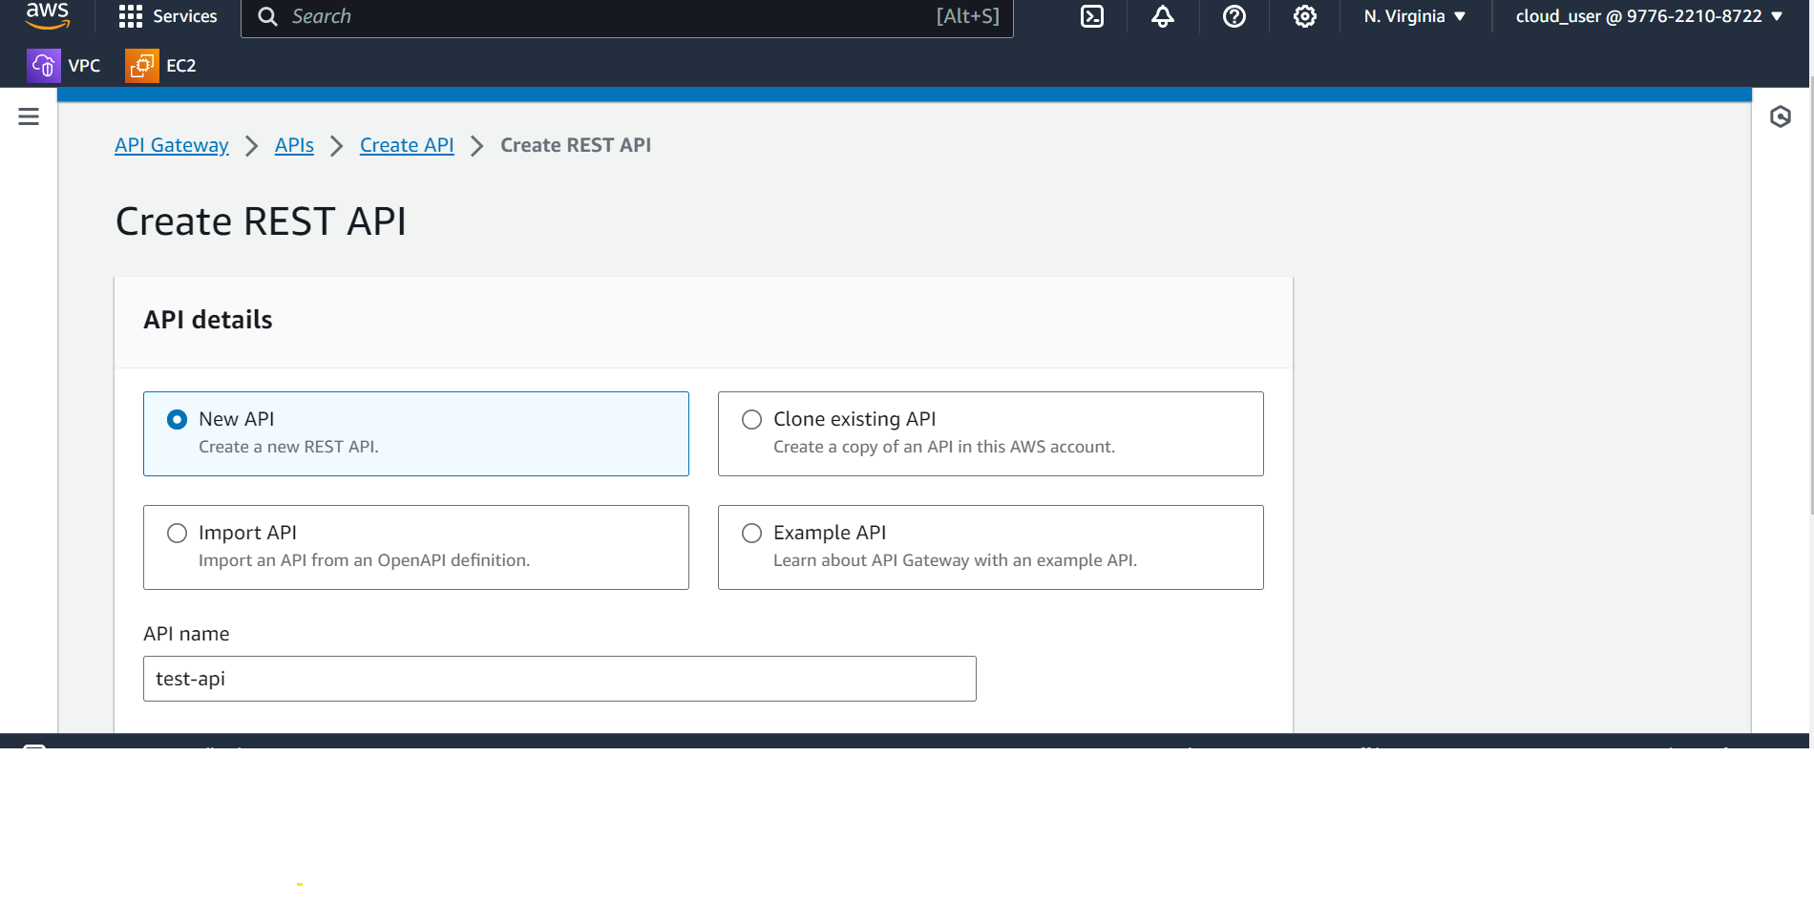

**Now we have to select the METHOD we want to use**

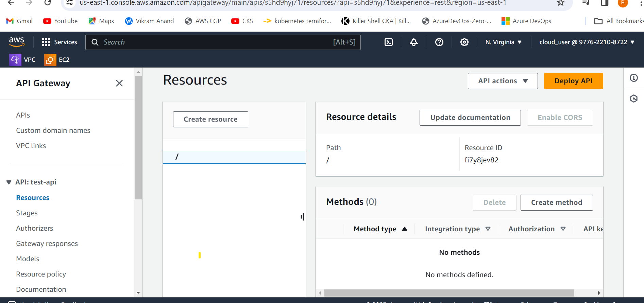

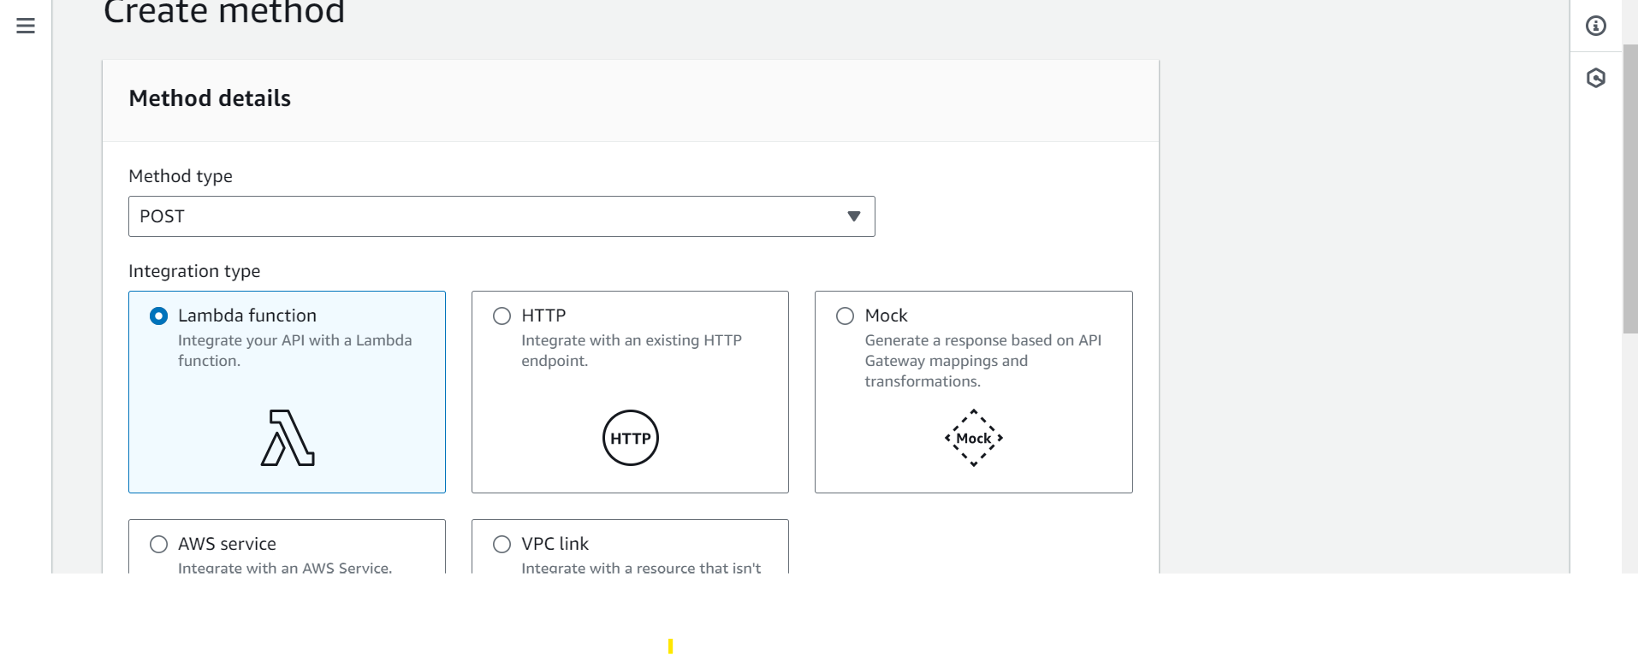

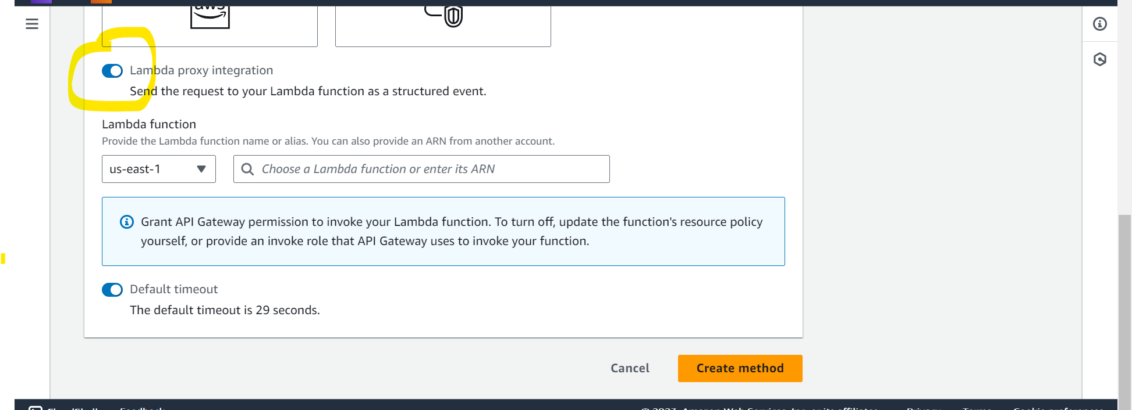

**Also specify the lambda we will be using for the METHOD we choose**

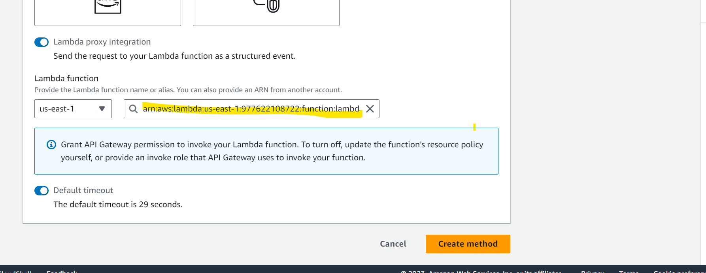

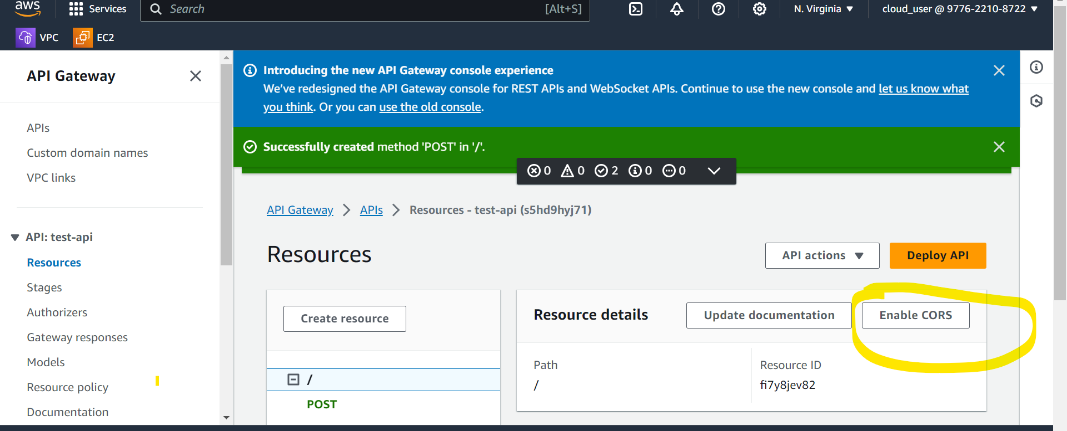

**We then deploy the API**

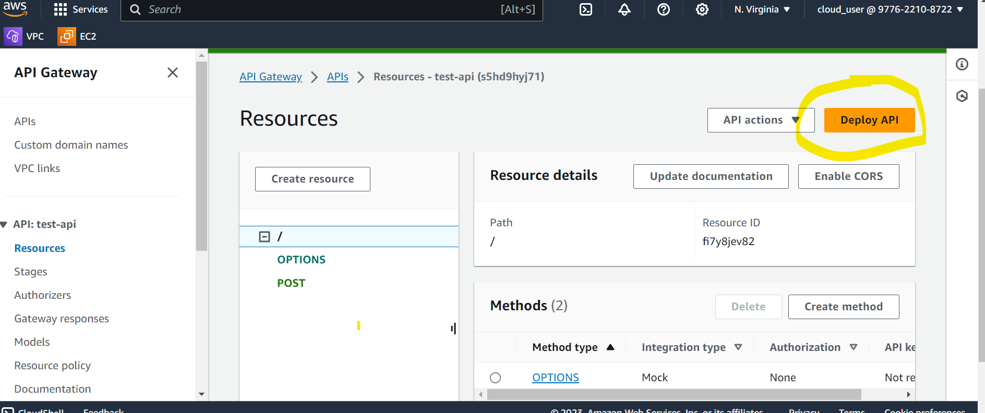

This will give the invoke URL . when this URL gets invoke it will trigger the lambda function.

**https://s5hd9hyj71.execute-api.us-east-1.amazonaws.com/dev**

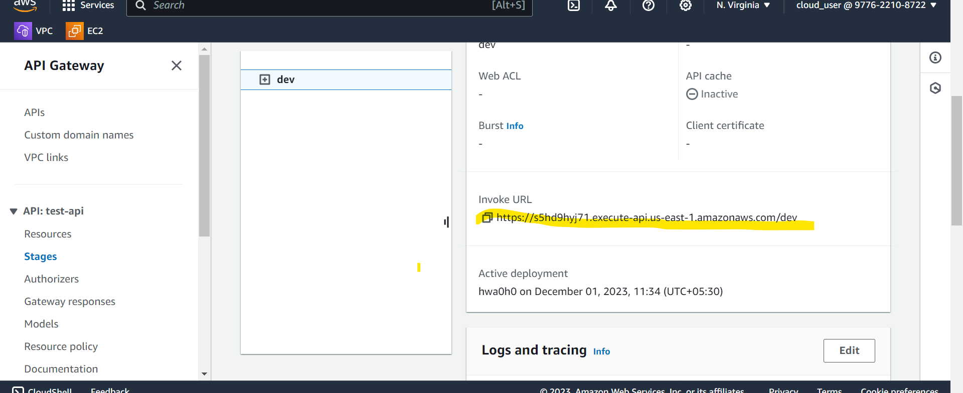

**Now we have to use some third party tool to invoke the Invoke URL.**

Below is the URL we can use.

Hit this in the browser

htmlpreview.github.io/?https://github.com/gaurav157243/aws-projects/blob/main/serverless/index.html

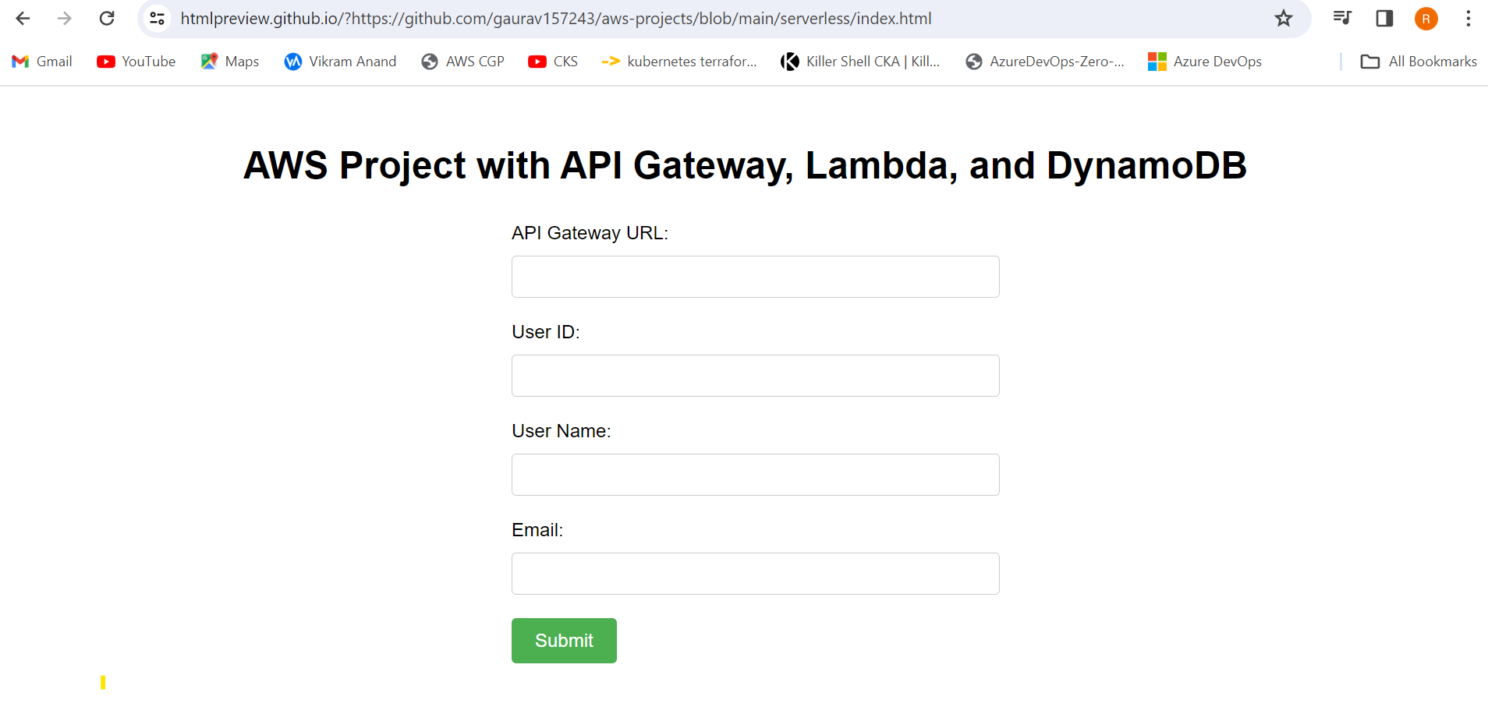

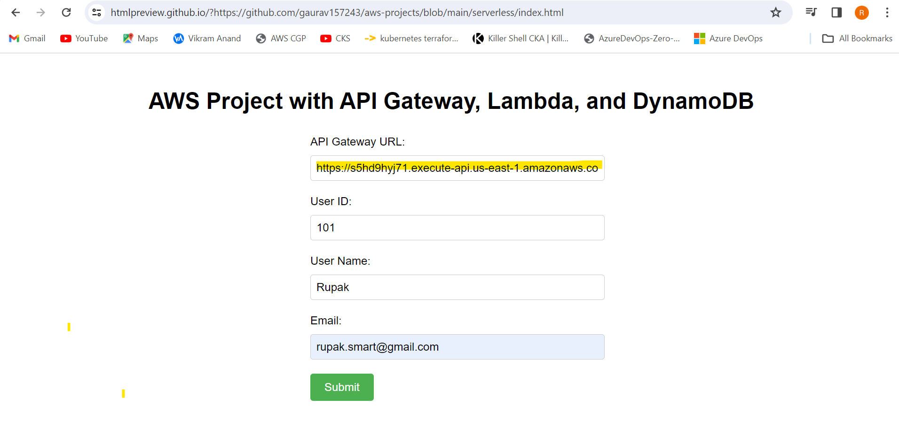

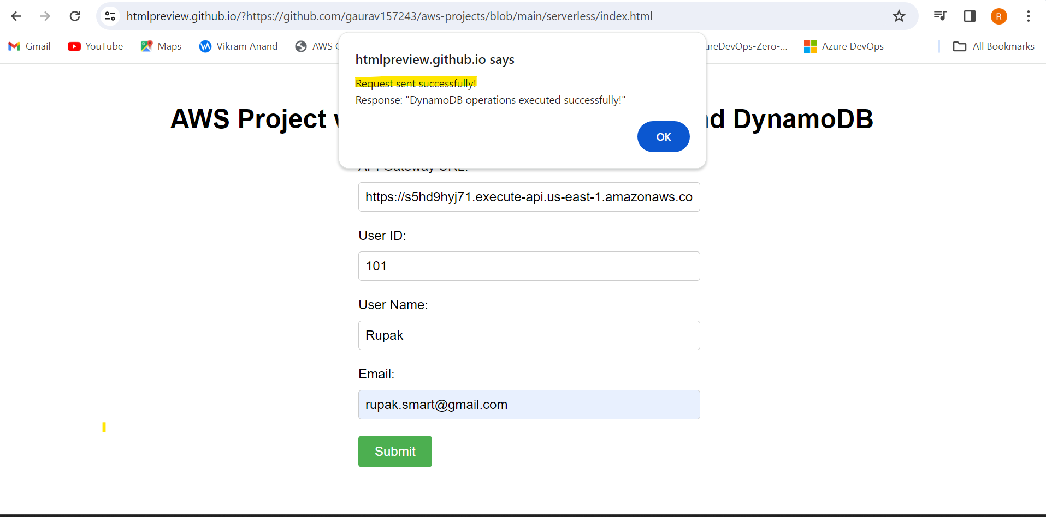

**This data will get stored in dynamodb table**

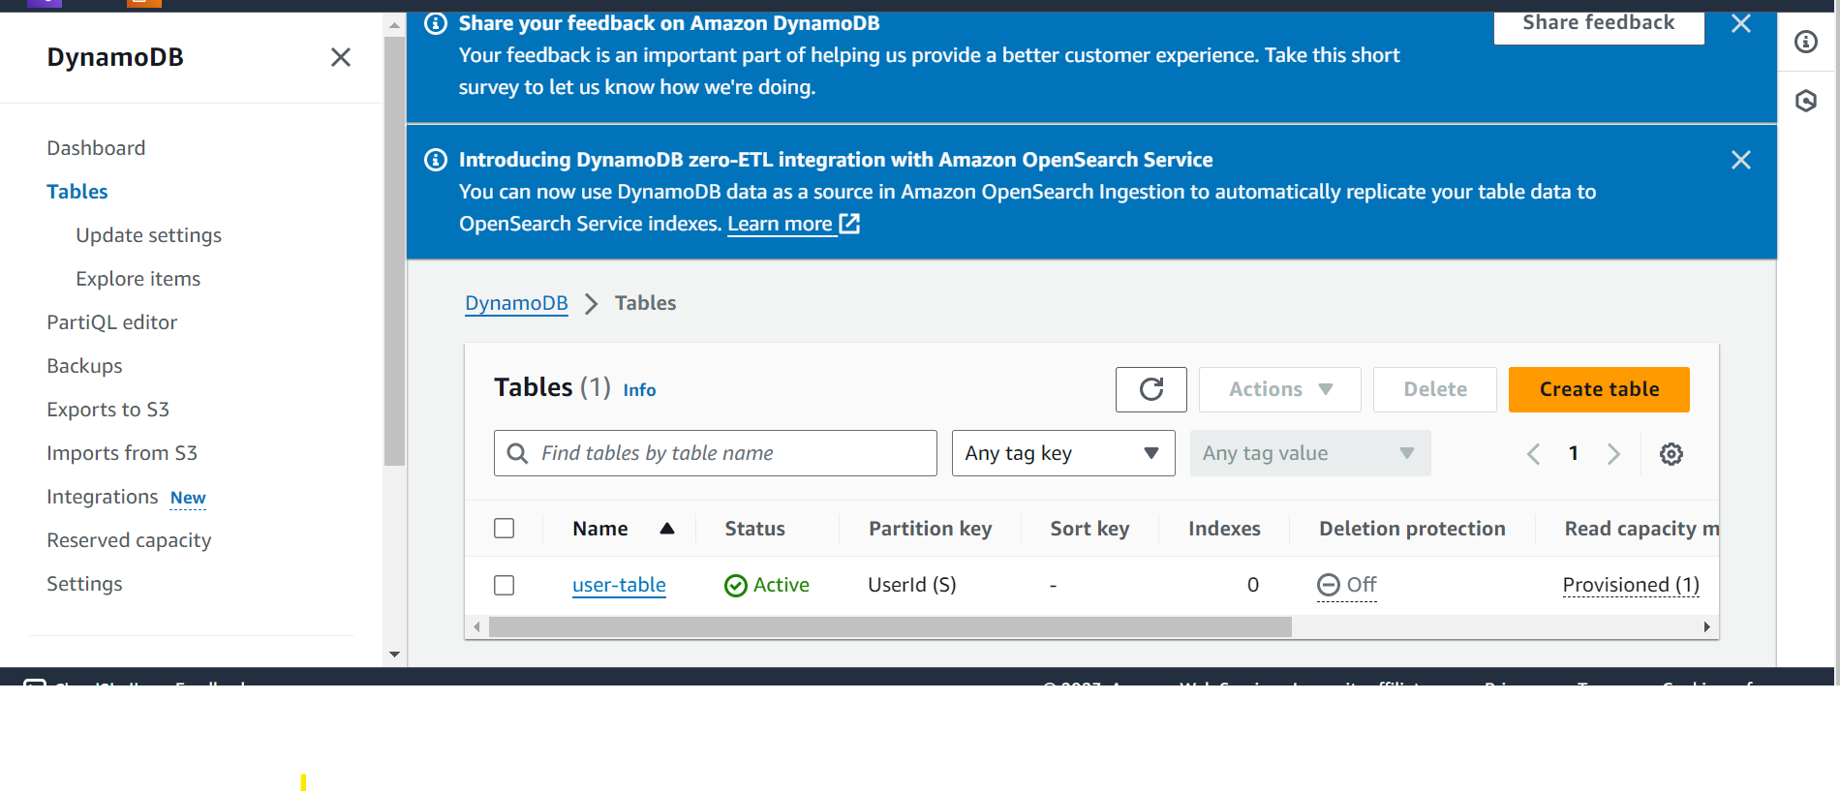

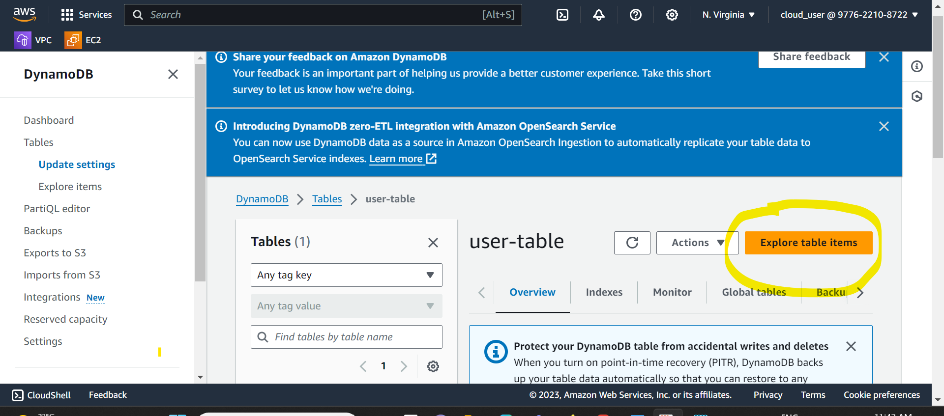

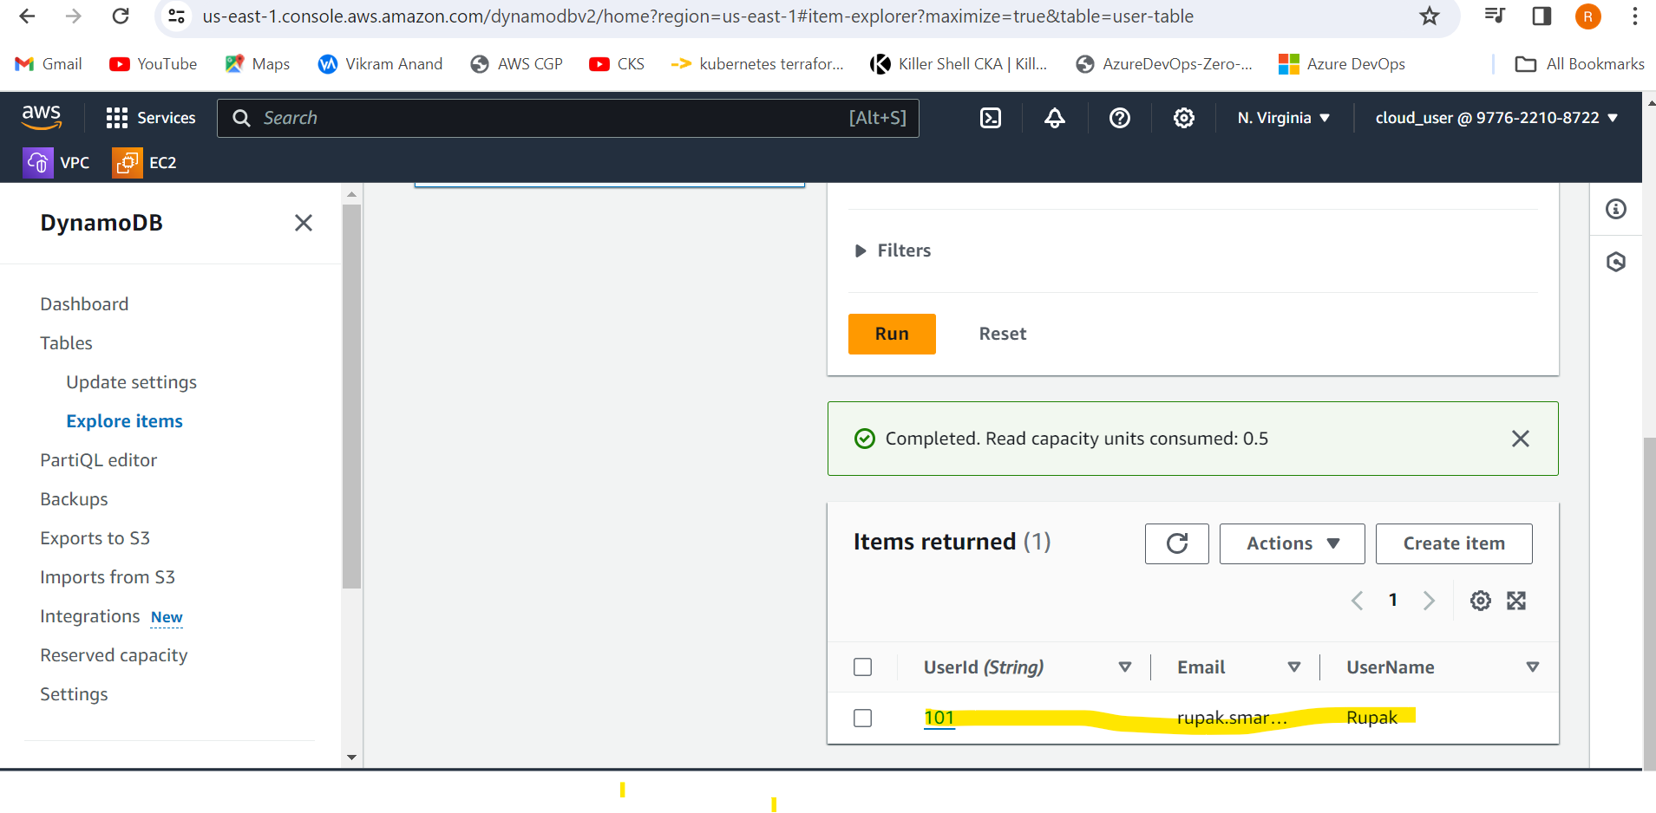

**Using POSTMAN**

